Review Task

**Table of Contents**

Review Task: 2

UI Changes 2

Create Task 2

Open Task 3

Closed Task 3

# Review Task:

1. Only users with the access to "Manage Page" will be able to create new tasks and assign tasks.
2. When a task is created by an admin, there will be an option to assign the task to a specific user.
   1. To do so, an additional field will be added to the current screen, which includes the following fields:
      1. User Name: The name of the user to whom the task is to be assigned.
      2. Role: The role of the user, which will be fetched automatically from the system.
3. Email Notifications: Once a task is assigned, the assignee will receive an email notification. The email will contain the following detail.
   1. Subject Line : A new Task has been assigned to you
   2. The email should contain - A link to go to the task list
   3. Should have the following details as well -
      1. Platform: The platform is related to the task on which the review is posted by the customer.
      2. Reviewer Name: The name of the person who has left the review.
      3. Comments: This comment refers to the reviewer post.
      4. Task Information/Description: This is the description field where the admin will provide input regarding the task if needed.
4. If the admin cannot find the user in the current list of users (within roles and permissions), the admin is responsible for creating new users and assigning them appropriate roles and permissions.
5. When any organization user will hit the "Open Task" button a screen will pop-up as mentioned in the "UI Change → Open Task".
   1. In the above mentioned pop-up screen, an "Assigned To" field will be added.
6. When a task is marked as completed and closed, two labels will be added to the task details:
   1. Assigned To: The name of the user to whom the task was assigned.
   2. Closed By: The name of the user who closed the task, which could be the admin or another authorized user.
   3. We should also have closing comments, Represented with a label as "Remark" which is already there.

# 

# UI Changes

## Create Task

1. The mentioned form appears when the admin hits the task button to assign the task.
2. On this screen, an additional field will be added, such as:
   1. Assigned to: The name of the user to whom the task is being assigned.
   2. Role: The role of the user, which will be fetched automatically from the system.

## Open Task

1. 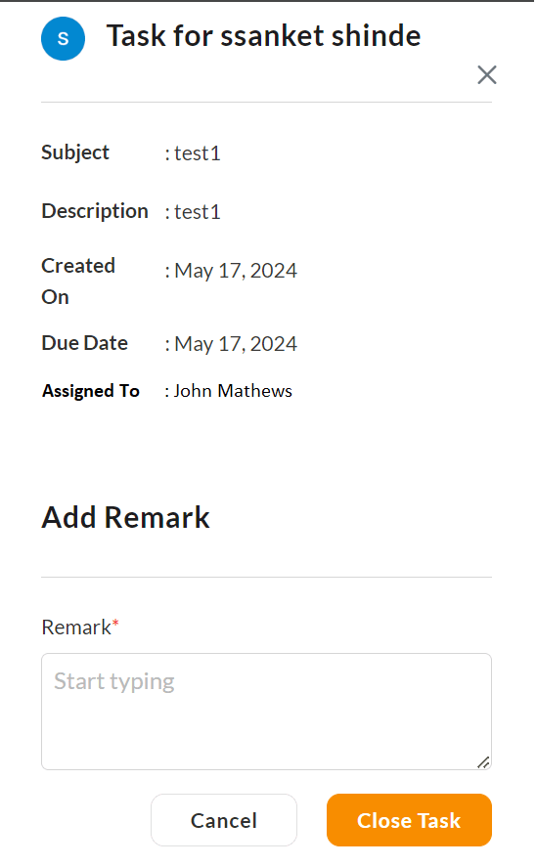This screen pop-ups when the open task button is hit by any users.
2. On this screen an addition of field "Assigned To" which will be of view type and show the user name to whom the task is assigned.

## Closed Task

1. 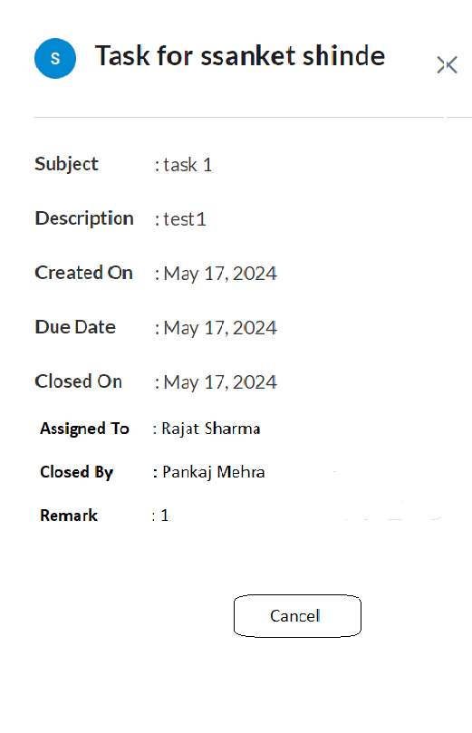This screen pop-ups when the open task button is hit by any users.
2. On this screen an addition of fields such as:
   1. Assigned To: The name of the user to whom the task was assigned.
   2. Closed By: The name of the user who closed the task, which could be the admin or another authorized user.

# 